**COMPUTER ORGANIZATION AND ASSEMBLY LANGUAGE**

**ASSIGNMENT#03**

**SUBMITTED BY:** HUZEFA SAIFUDDIN - 22K-5125

**SUBMITTED TO:** SIR KASHAN HUSSAIN

**DATE:** 3rd SEPTEMBER,2023

## QUESTION #1:

**CODE:**

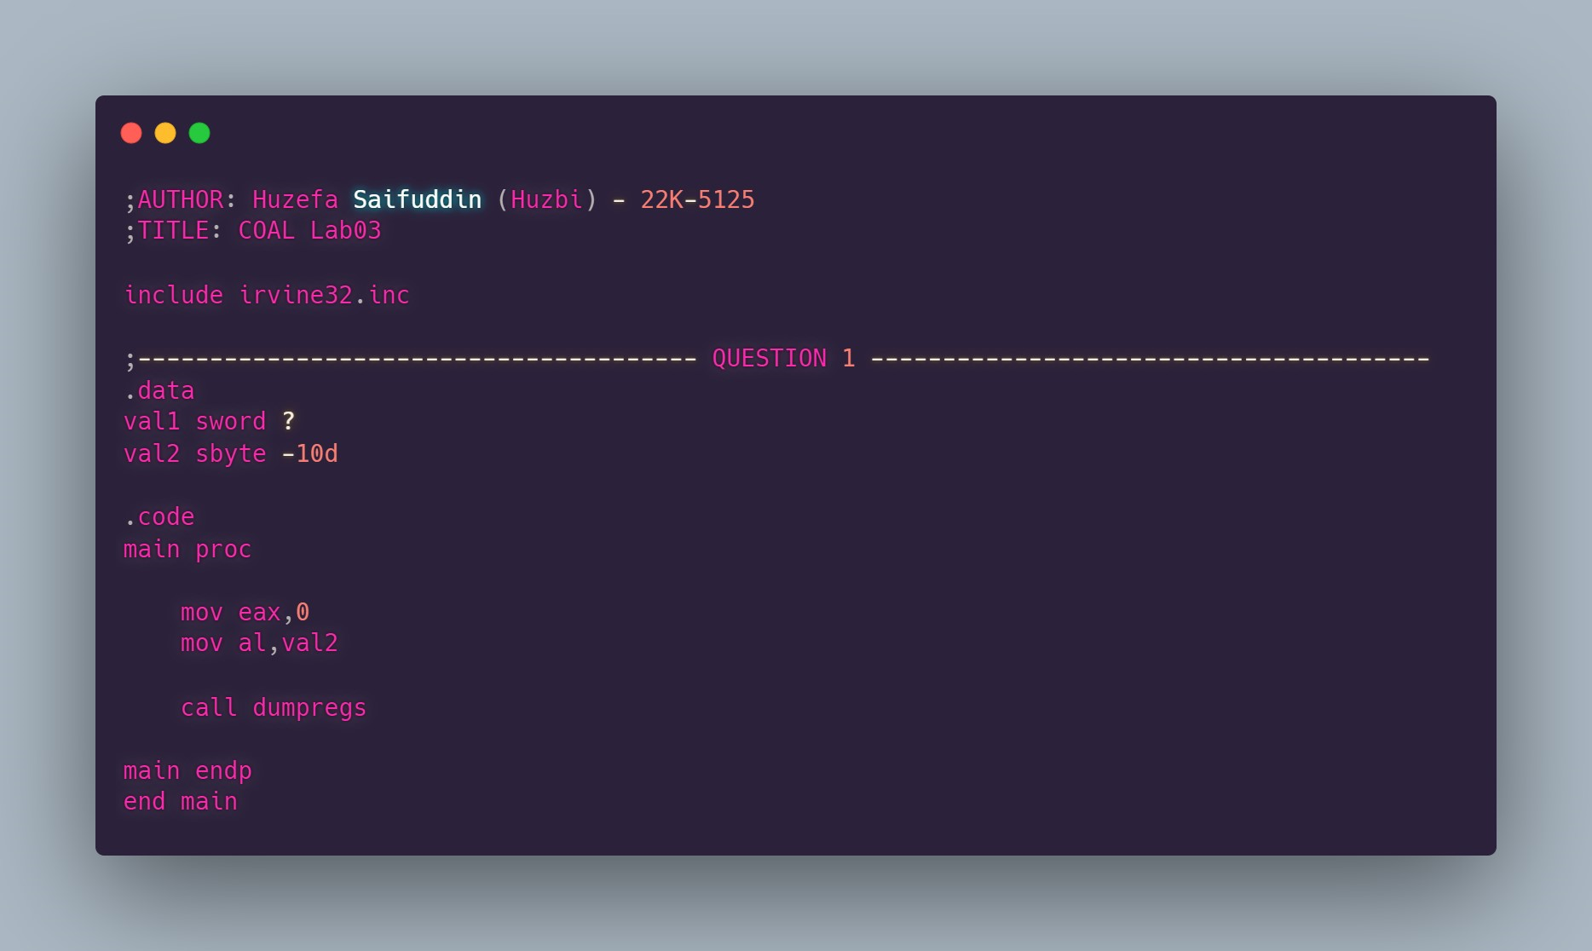

**OUTPUT:**

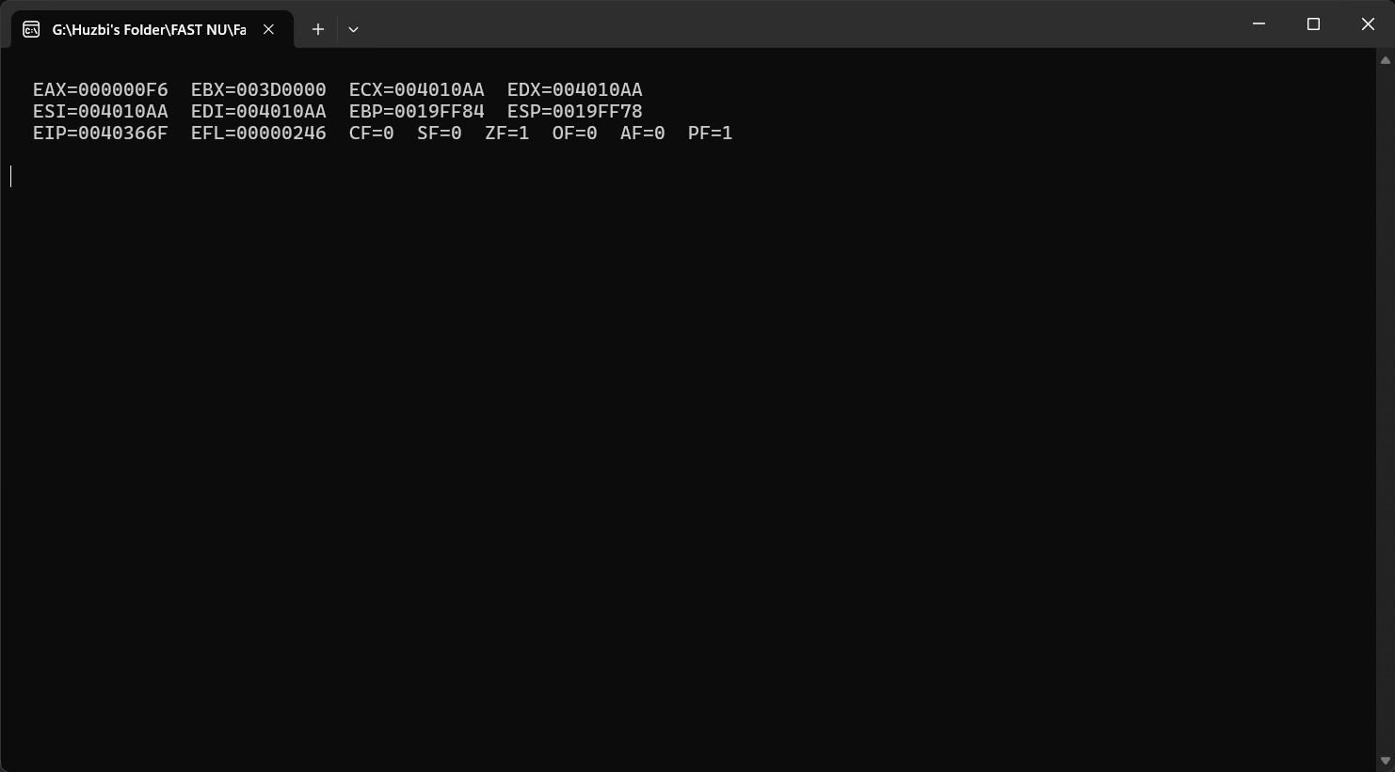

**REGISTER VALUES:**

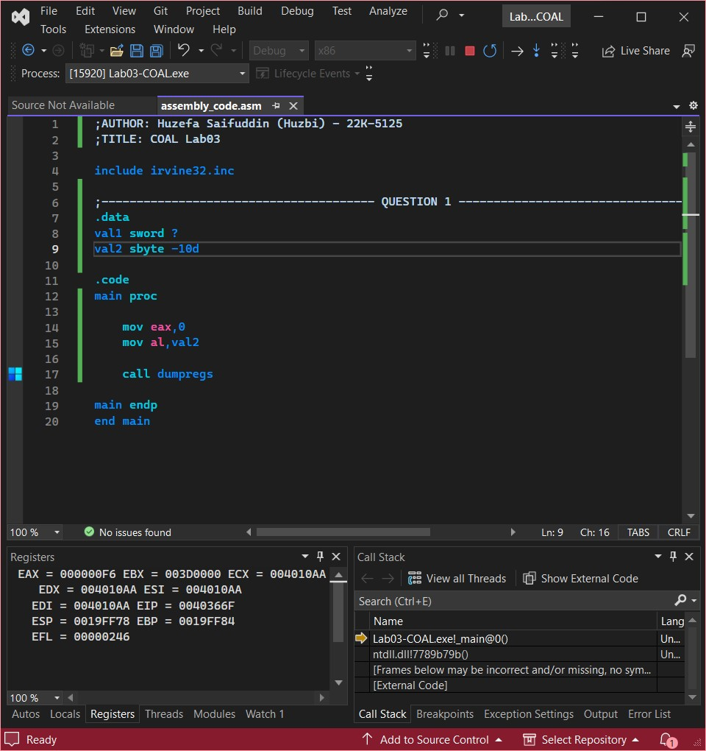

## QUESTION #2:

**CODE:**

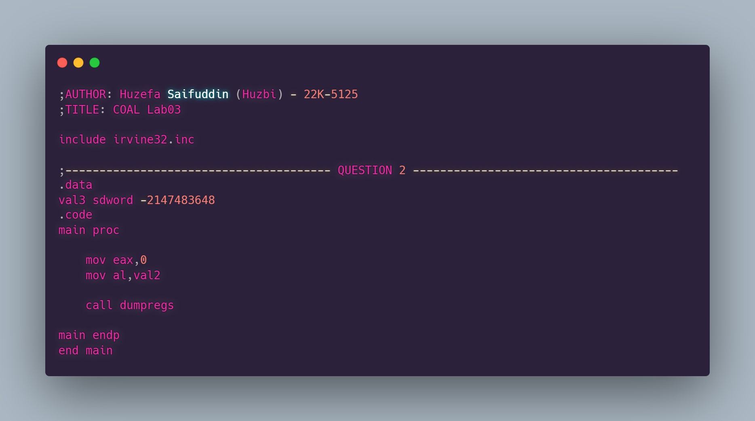

**OUTPUT:**

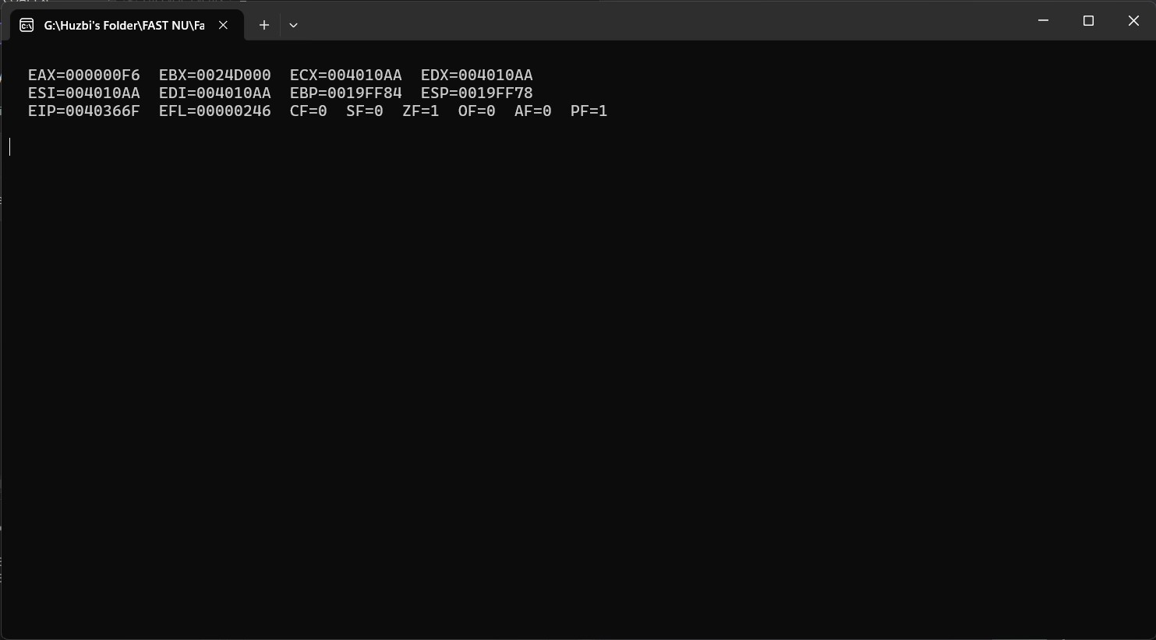

**REGISTER VALUES:**

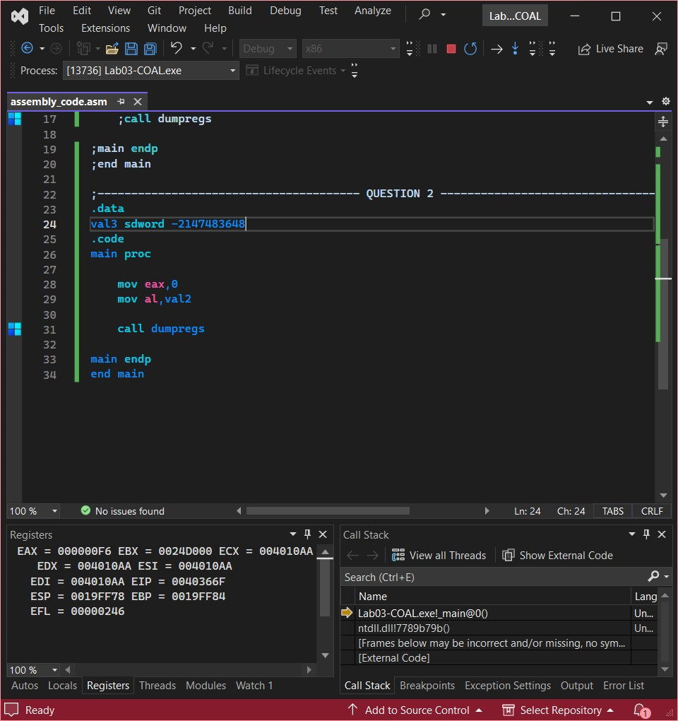

## QUESTION #3:

**CODE:**

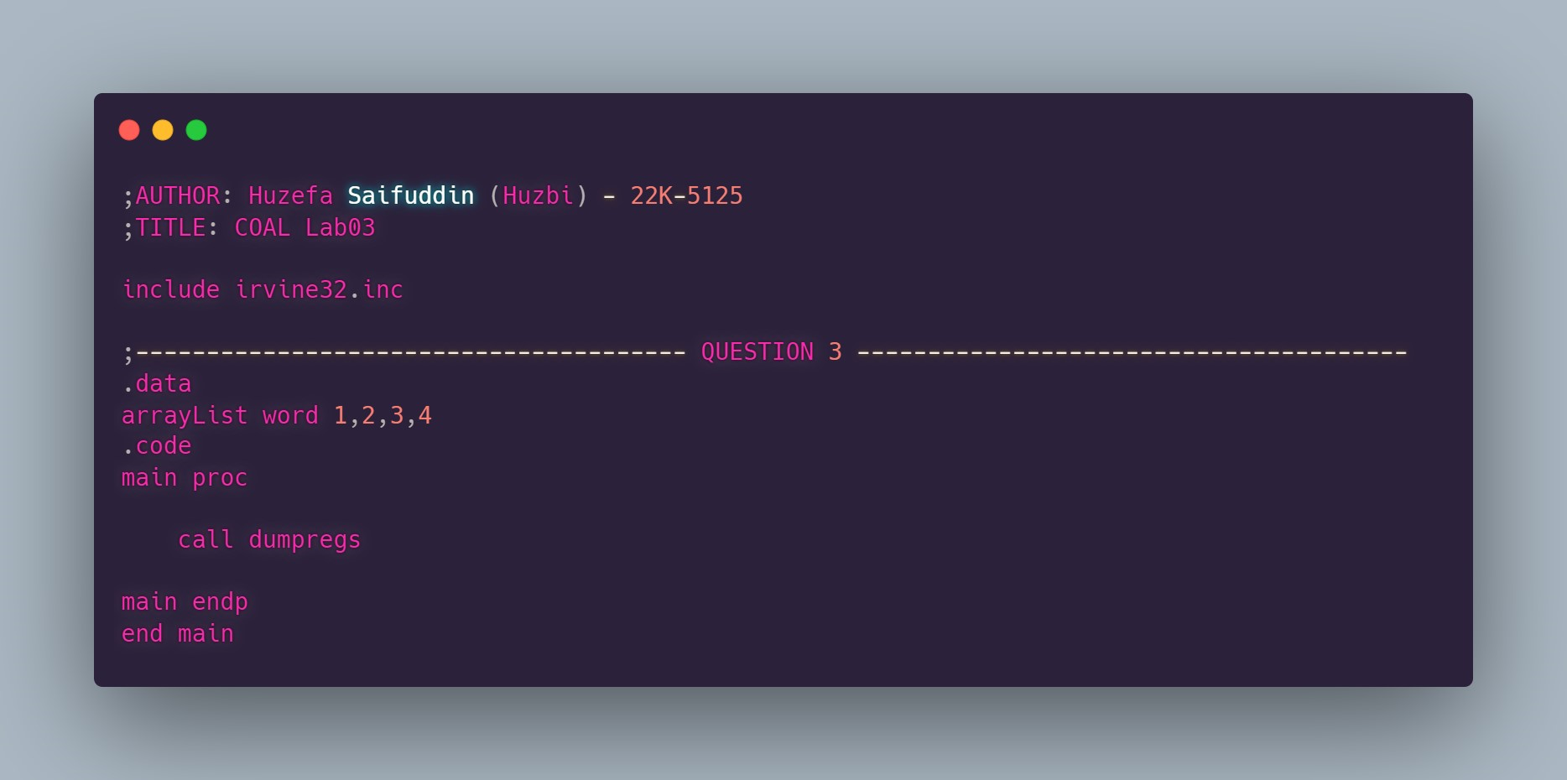

**OUTPUT:**

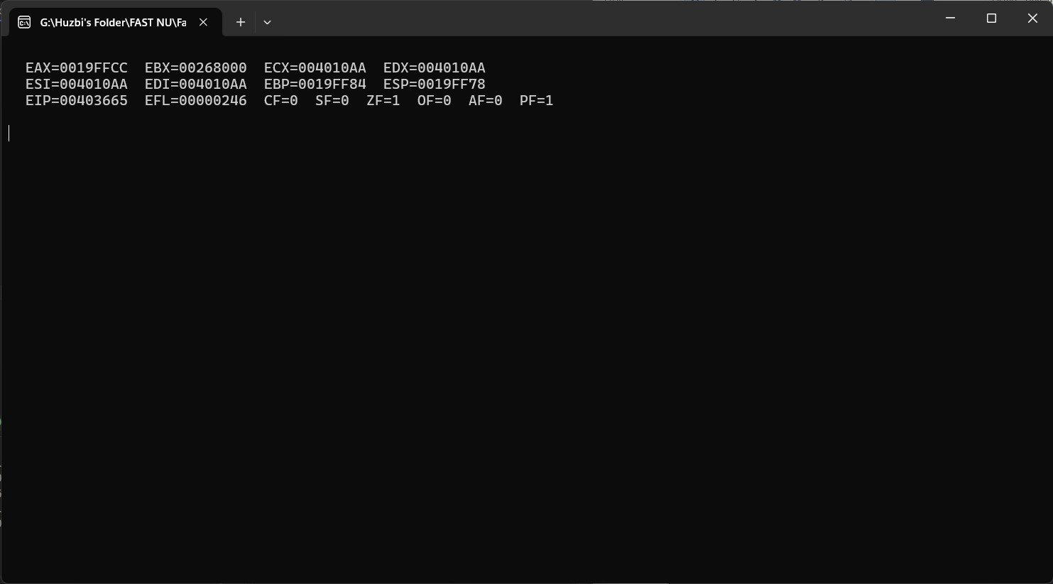

**REGISTER VALUES:**

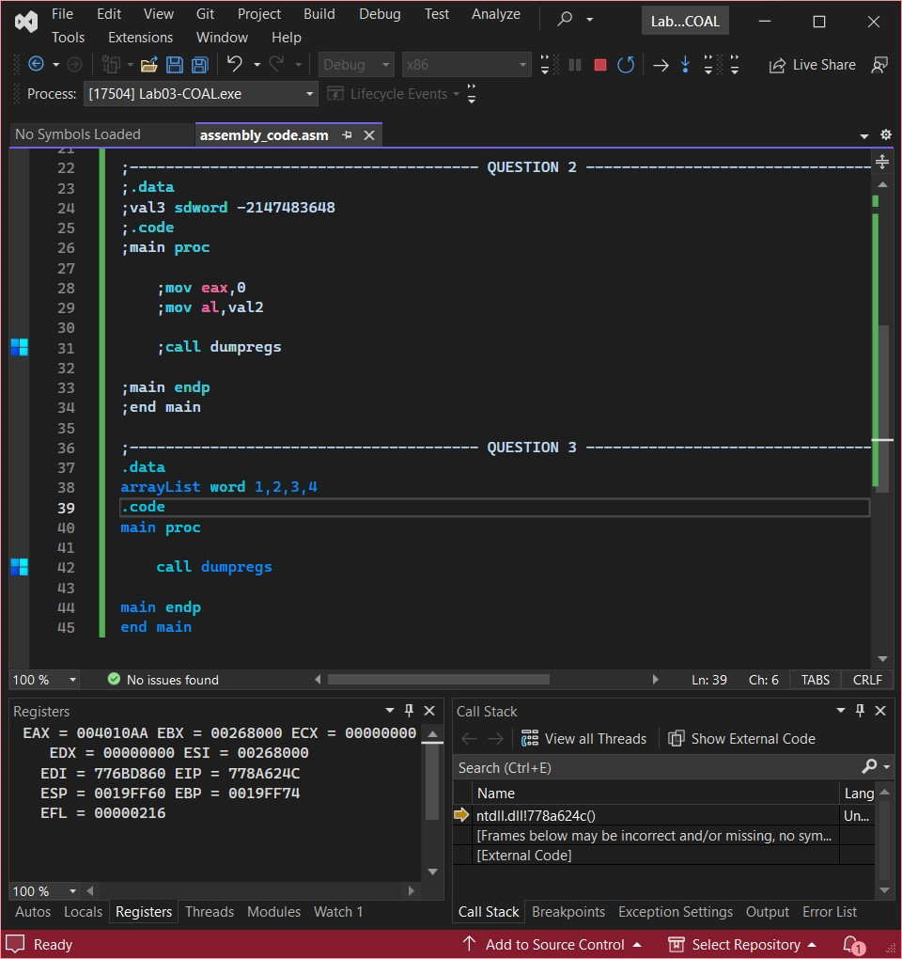

## QUESTION #4:

**CODE:**

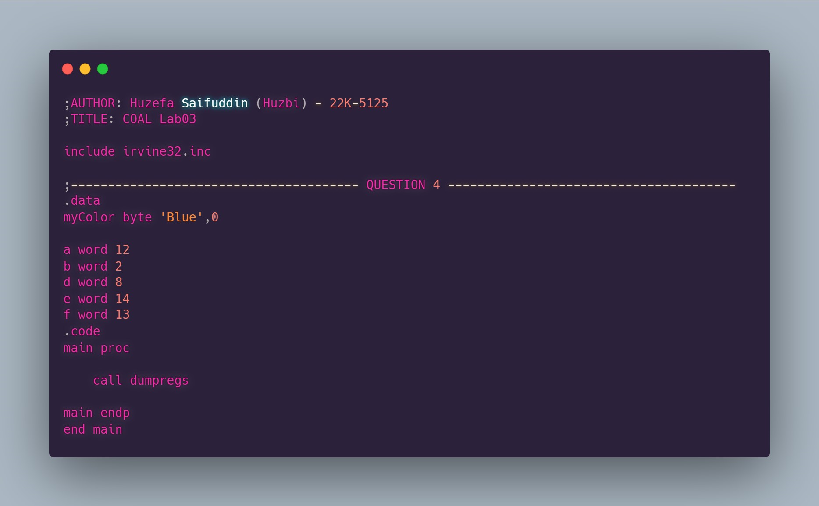

**OUTPUT:**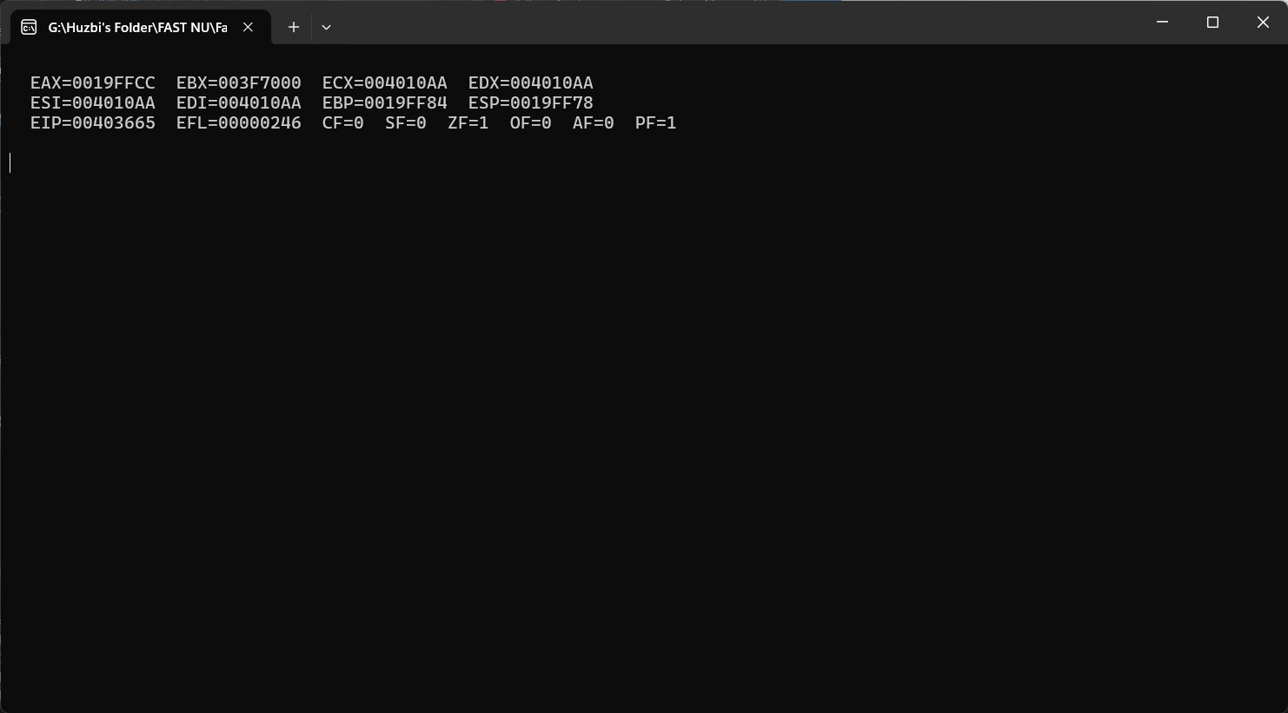

**REGISTER VALUES:**

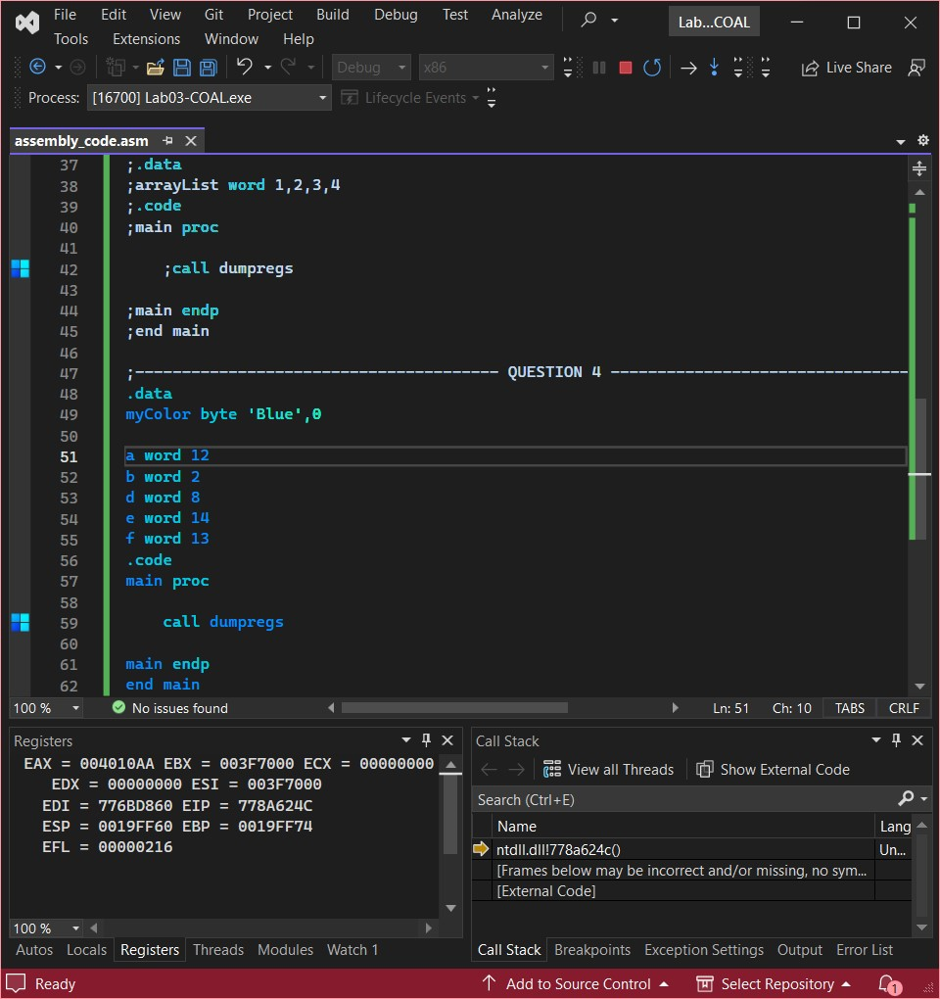

## QUESTION #5:

**CODE:**

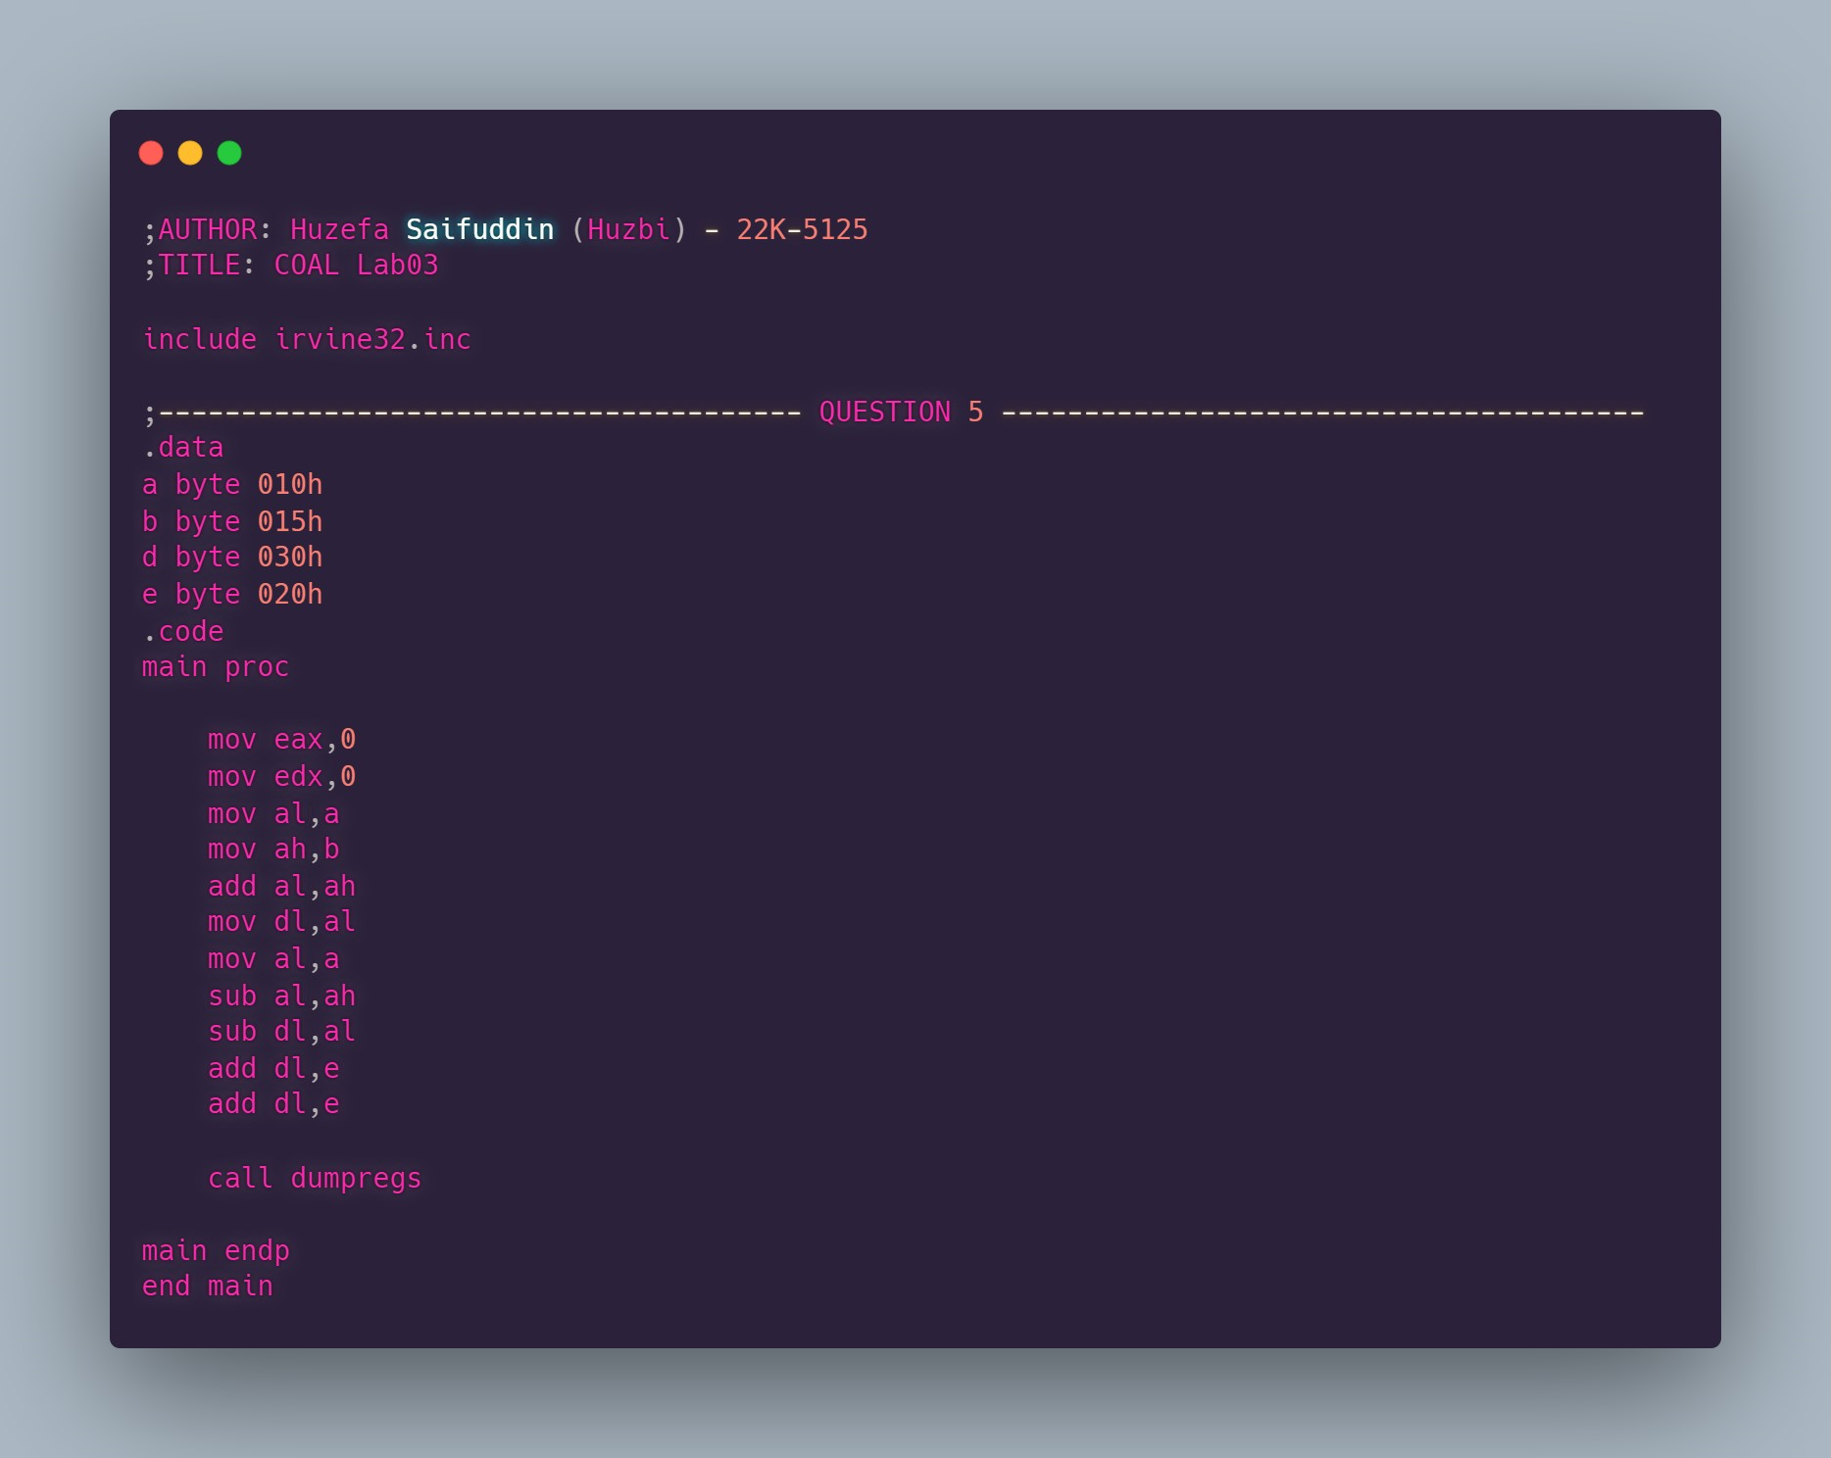

**OUTPUT:**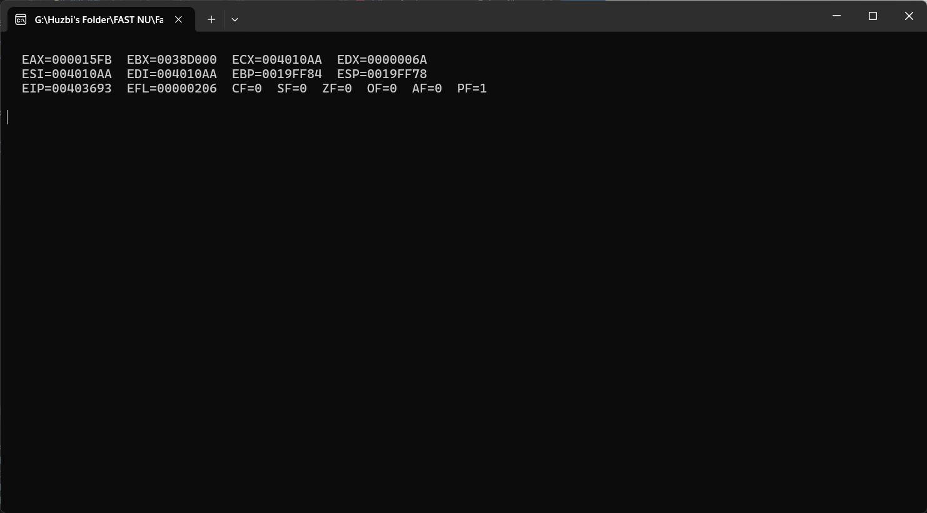

**REGISTER VALUES:**

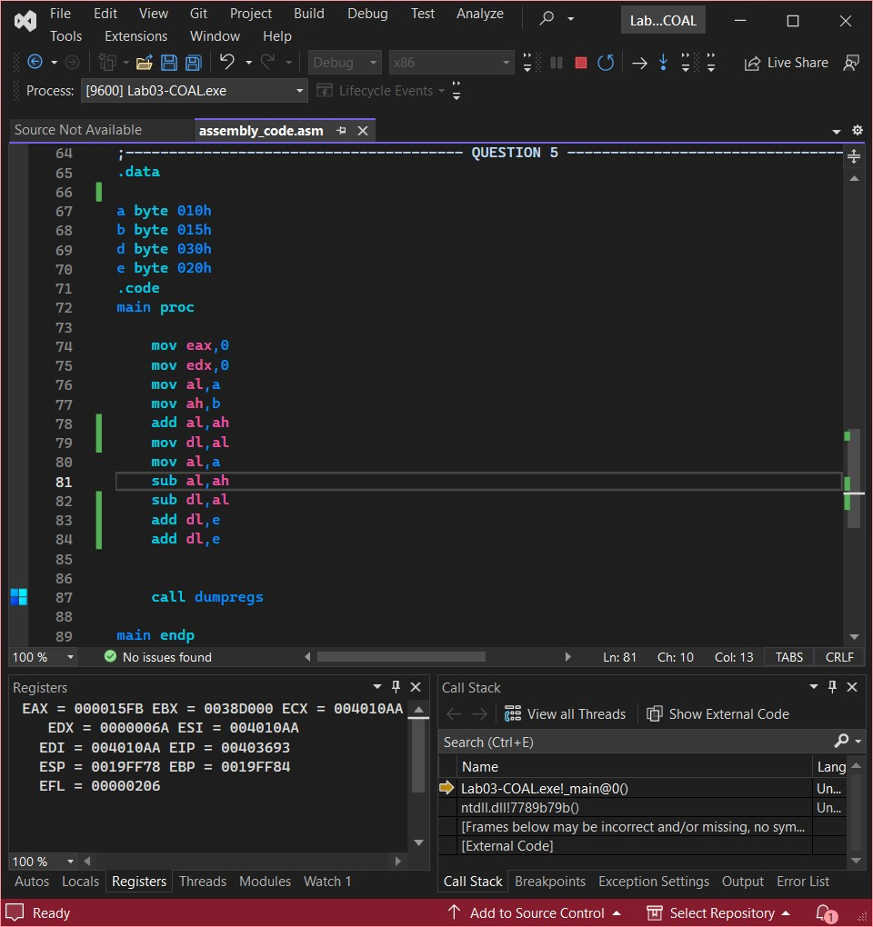

## QUESTION #6:

**CODE:**

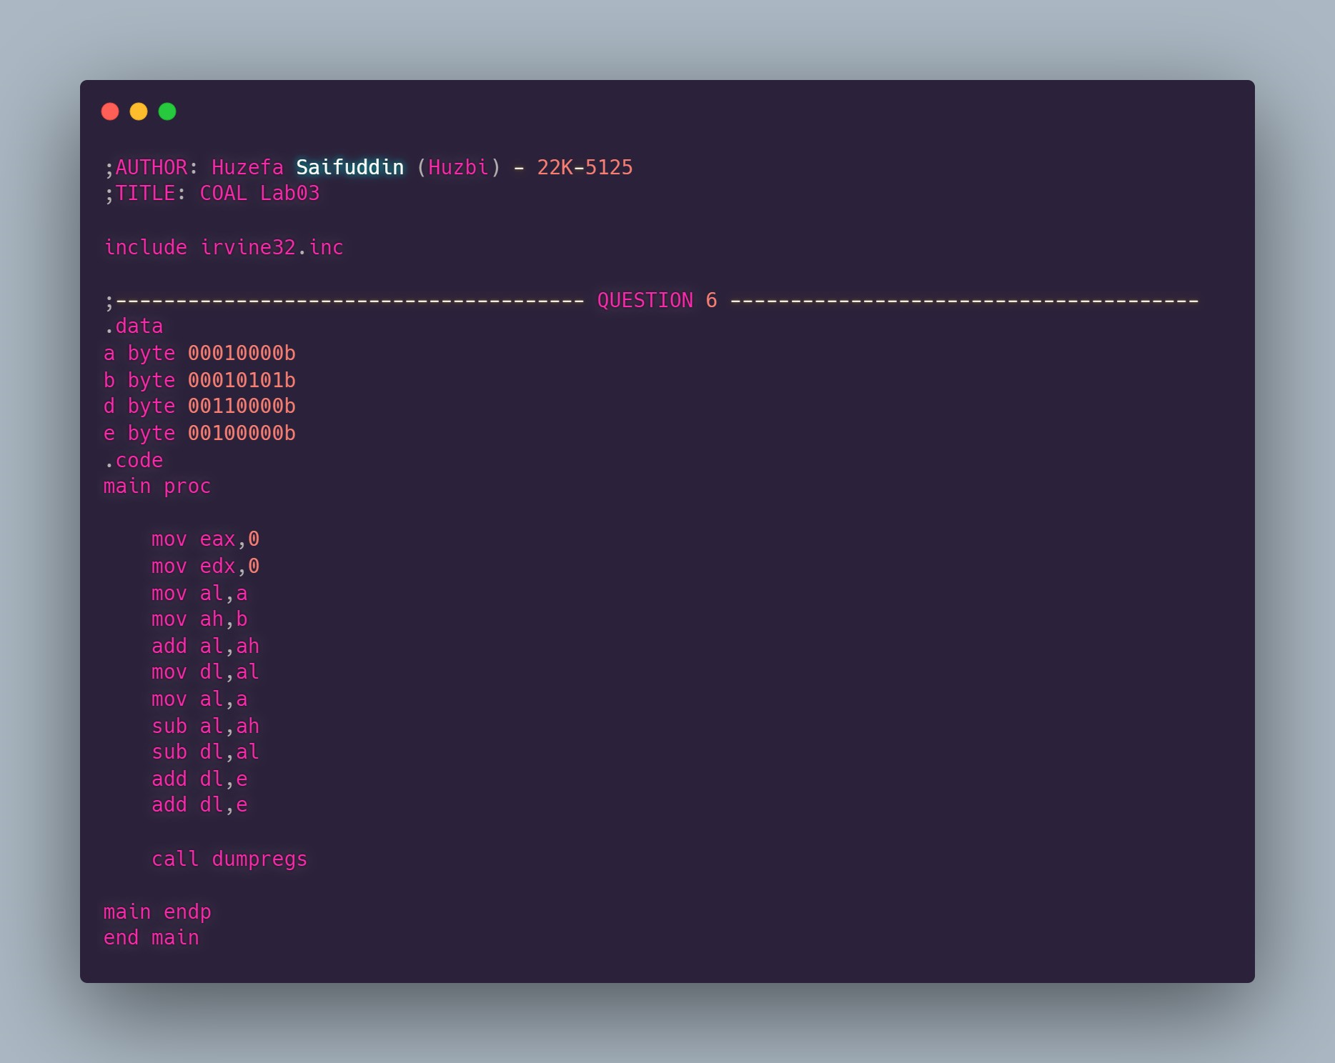

**OUTPUT:**

**REGISTER VALUES:**

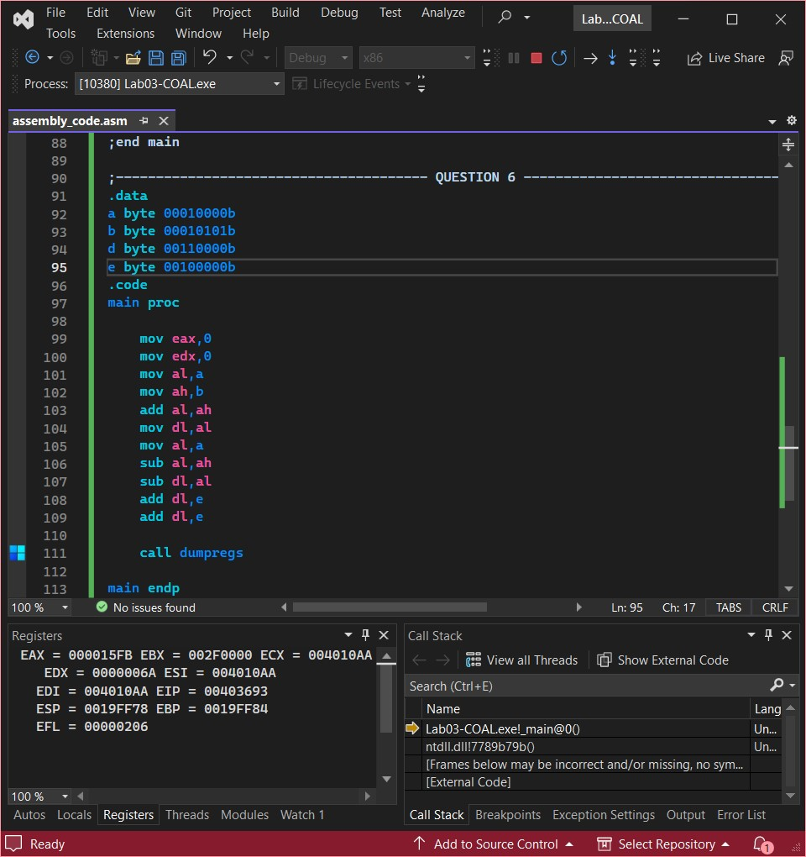

## QUESTION #7:

**CODE:**

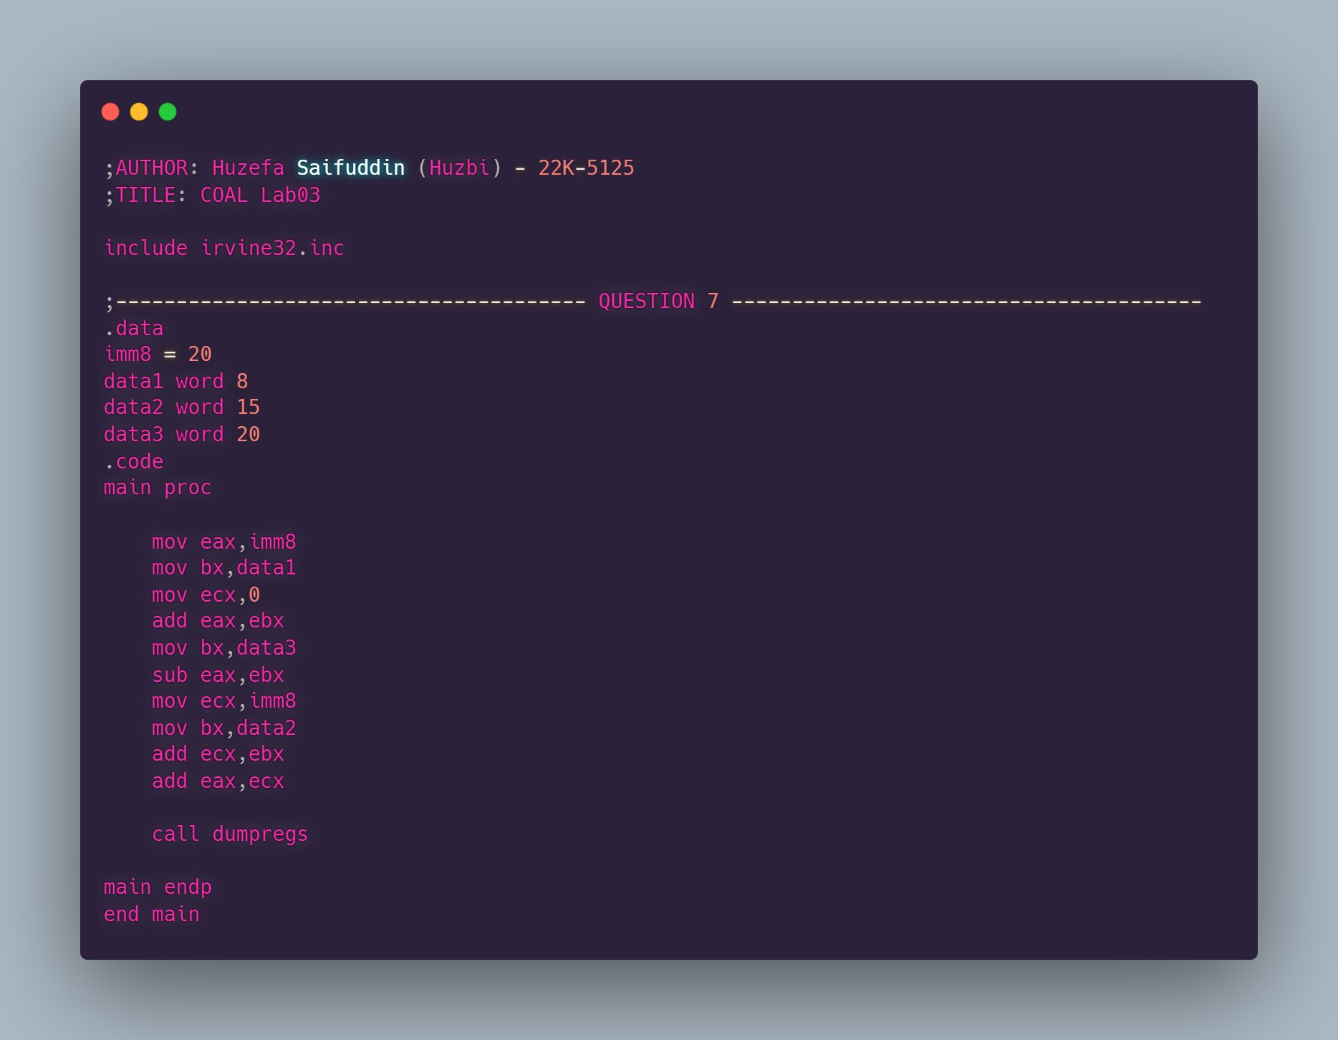

**OUTPUT:**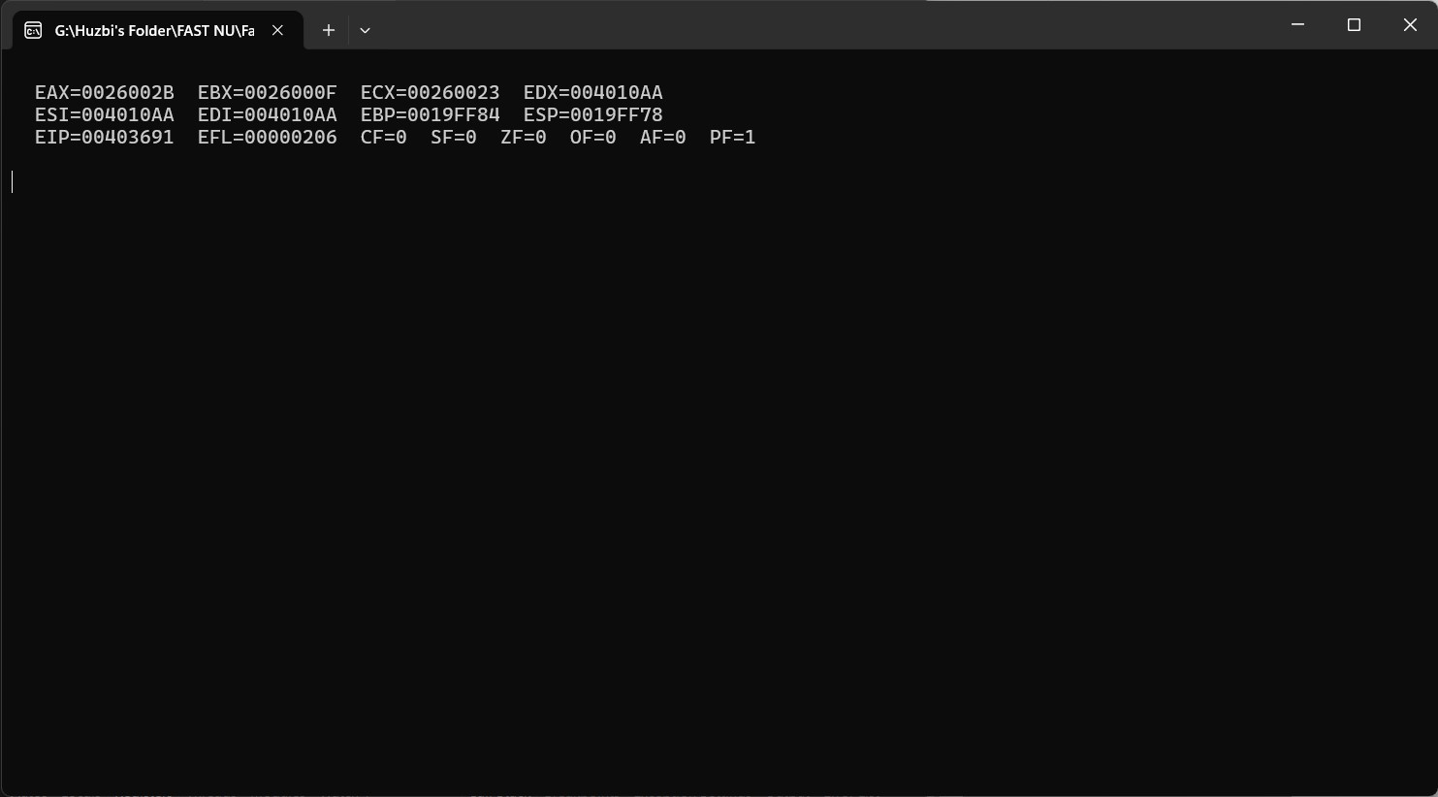

**REGISTER VALUES:**